PARTNER

GUIDE

OCT 2021

BY TEAM 12

VAN LANG UNIVERSITY

Family Health Care

Mentor

NGUYEN HUU QUOC

# **I. Introduction:**

## ***1. Goal:***

Describe user guide for Family Health Care

## ***2. Execute team:***

|  |  |
| --- | --- |
| Full name | Role |
| Tran Thi Yen Dang | Leader |
| Thai Nhat Quang | Member |
| Tran Le Anh Trung | Member |
| Tran Kien Tuong | Member |
| Tu Quang Anh | Member |
| Nguyen Hoang Hai | Member |

## ***3. Reader:***

|  |  |
| --- | --- |
| Reader | Content |
| Team 12 | II |
| User | II |

Table of Contents

**I. Introduction:** 2

***1. Goal:*** 2

***2. Execute team:*** 2

***3. Reader:*** 2

**II. User guide:** 4

2 Doctor View: 4

2.1 Login page as Doctor of the system 4

2.2 Logout page doctor of the system 4

2.3 Home page doctor of the system 5

2.4 Schedule Timing 5

2.5 Medical Records page of the system 6

2.6 Calendar page of the system 9

2.7 Profile setting Page of the system 9

3 Pharmacy View: 10

3.1 Login page as Pharmacy of the system 10

3.1.1 Homepage for Pharmacy 11

3.1.2 CRUD for Medicine: Management page "Medicine" for Pharmacy, can add delete and edit products 12

3.1.3 CRUD for Prescription: Management page "Prescription" for Pharmacy, can add delete and edit products 18

3.1.4 View Notifications 21

3.1.5 Change Password 22

3.1.6 Change Languages 22

3.1.7 Settings Website 23

# **II. User guide:**

# Doctor View:

## Login page as Doctor of the system

Login:

* Step 1: Enter login information as "Doctor" (1)
* Step 2: Click the "Login" button to login (2)
* Step 3: Website will display homepage

## Logout page doctor of the system

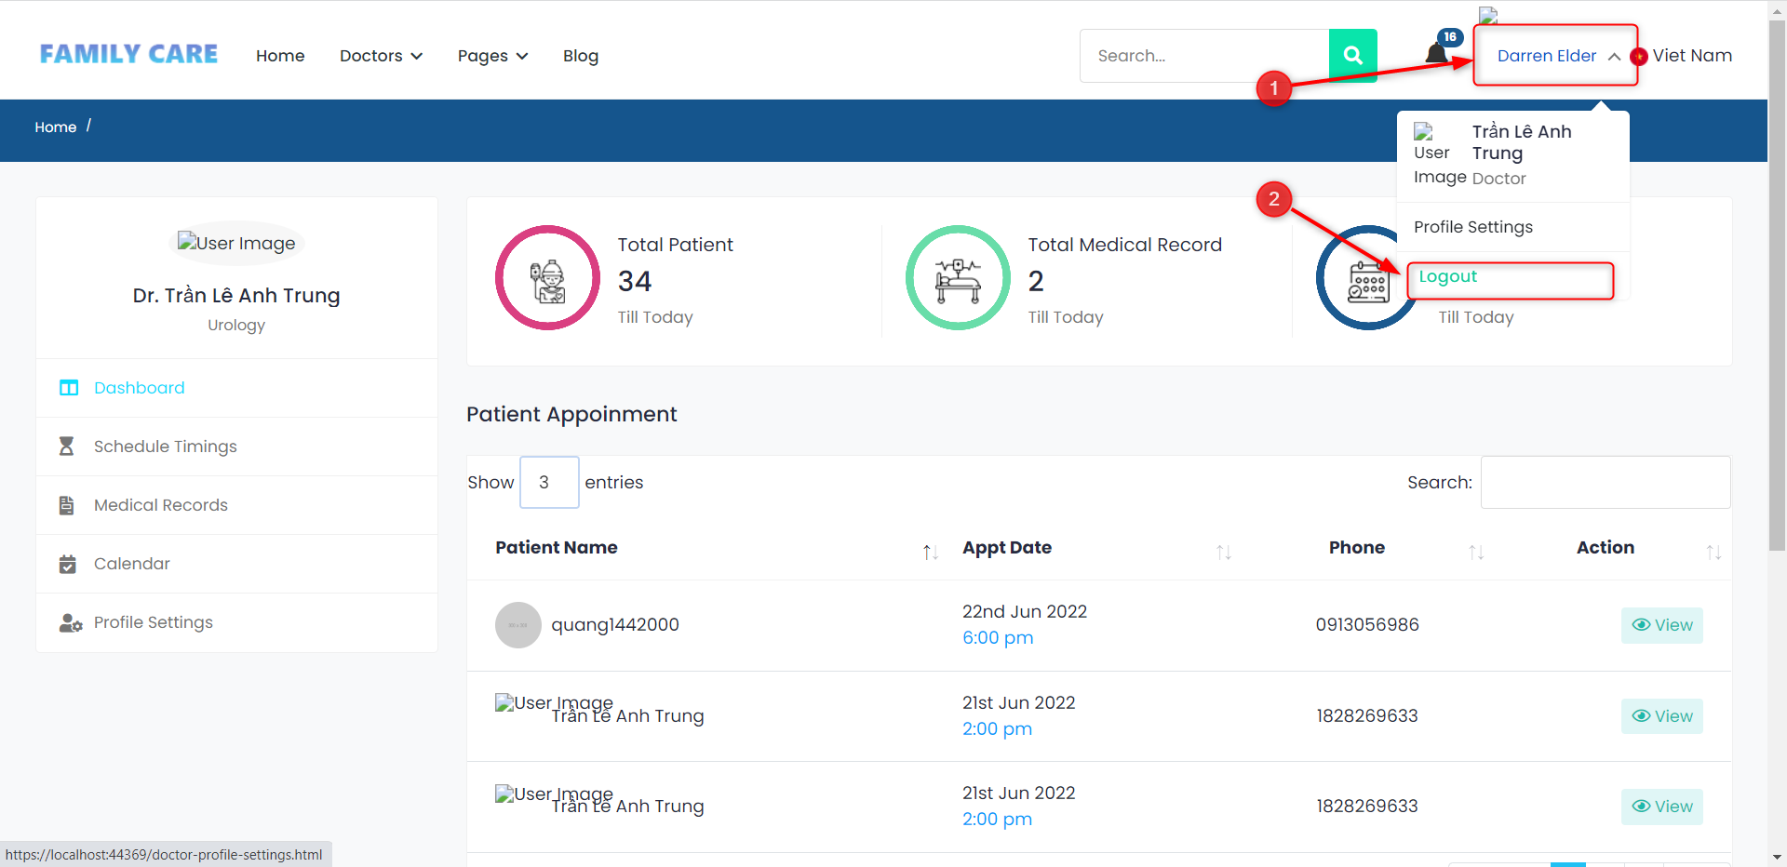

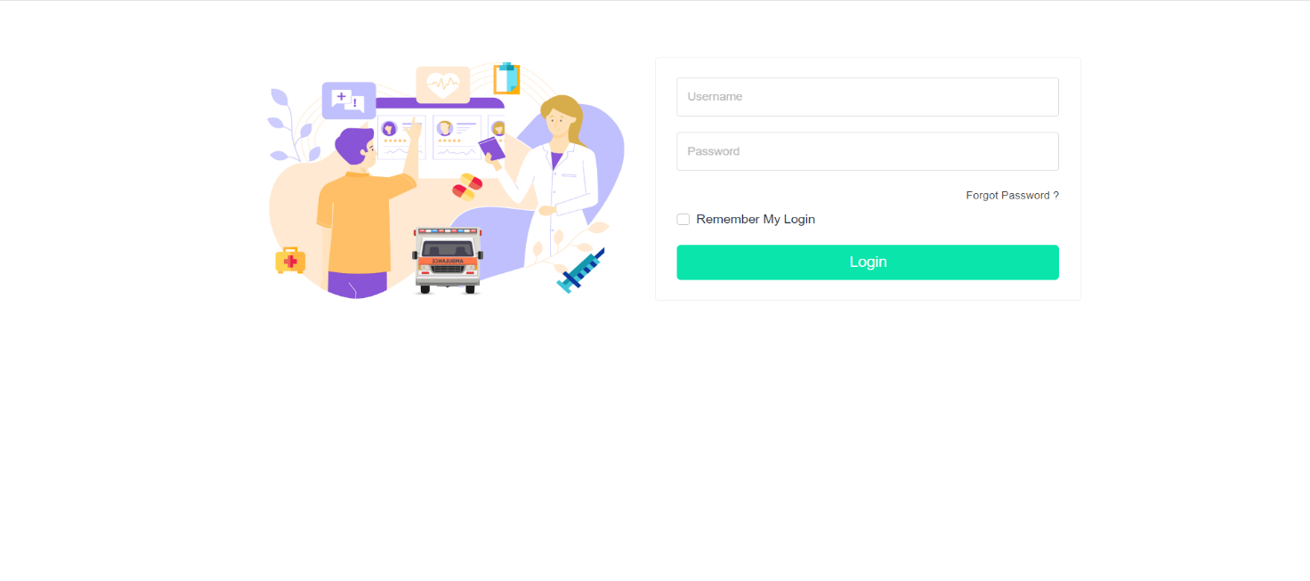

Logout page doctor of the system

* Step 1: Click on Avatar (1).
* Step 2: Click Log out (2).
* Step 3: Back to Login Page (3).

## Home page doctor of the system

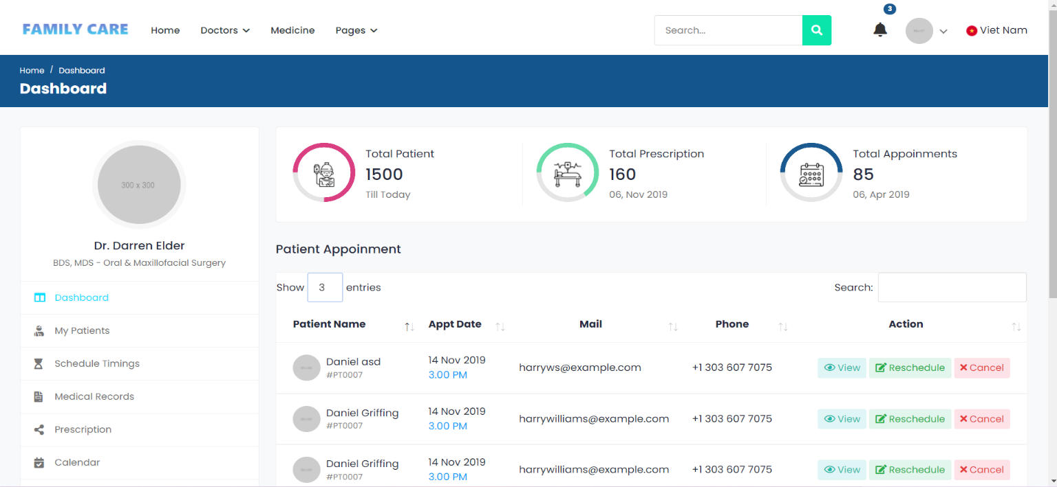

## Schedule Timing

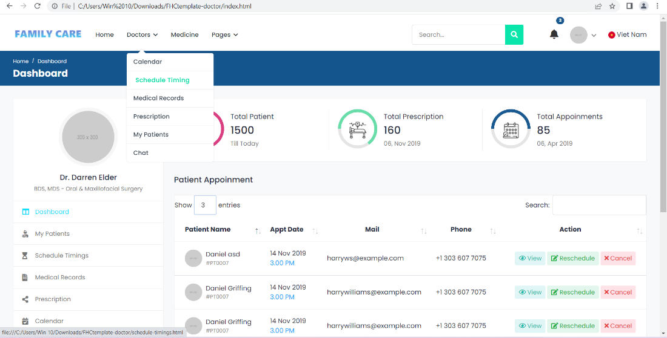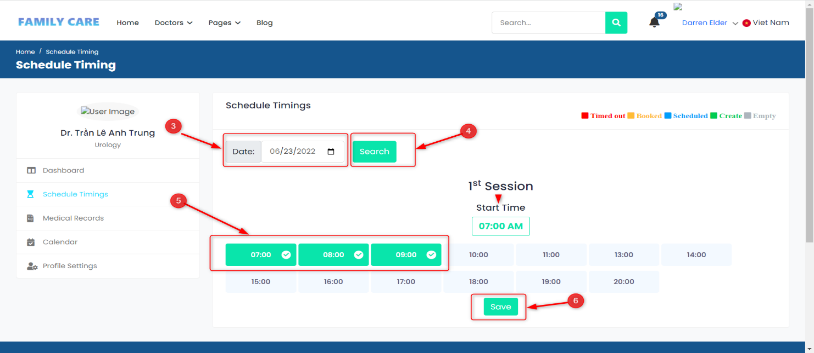

Schedule Timings:

* Step 1: Click to " Doctor " (1)
* Step 2: Click on " Schedule Timings " to set up work schedule (1)
* Step 3: Select the date you want to register (3) and press the search button (4)
* Step 4: Select on time you want to register (5)
* Step 5: Click button Save

## Medical Records page of the system

View medical record for Doctor:

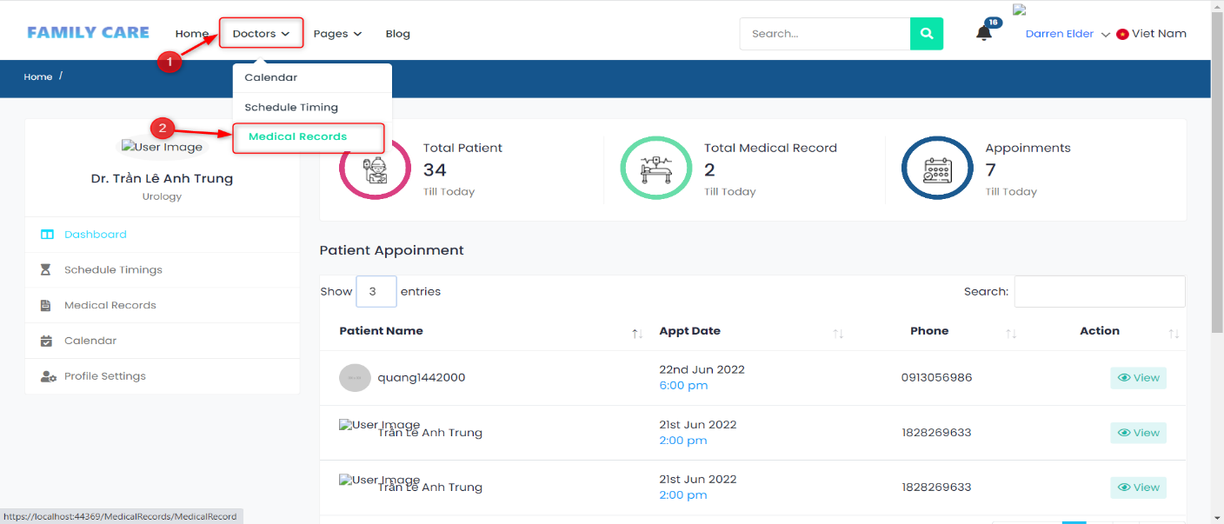

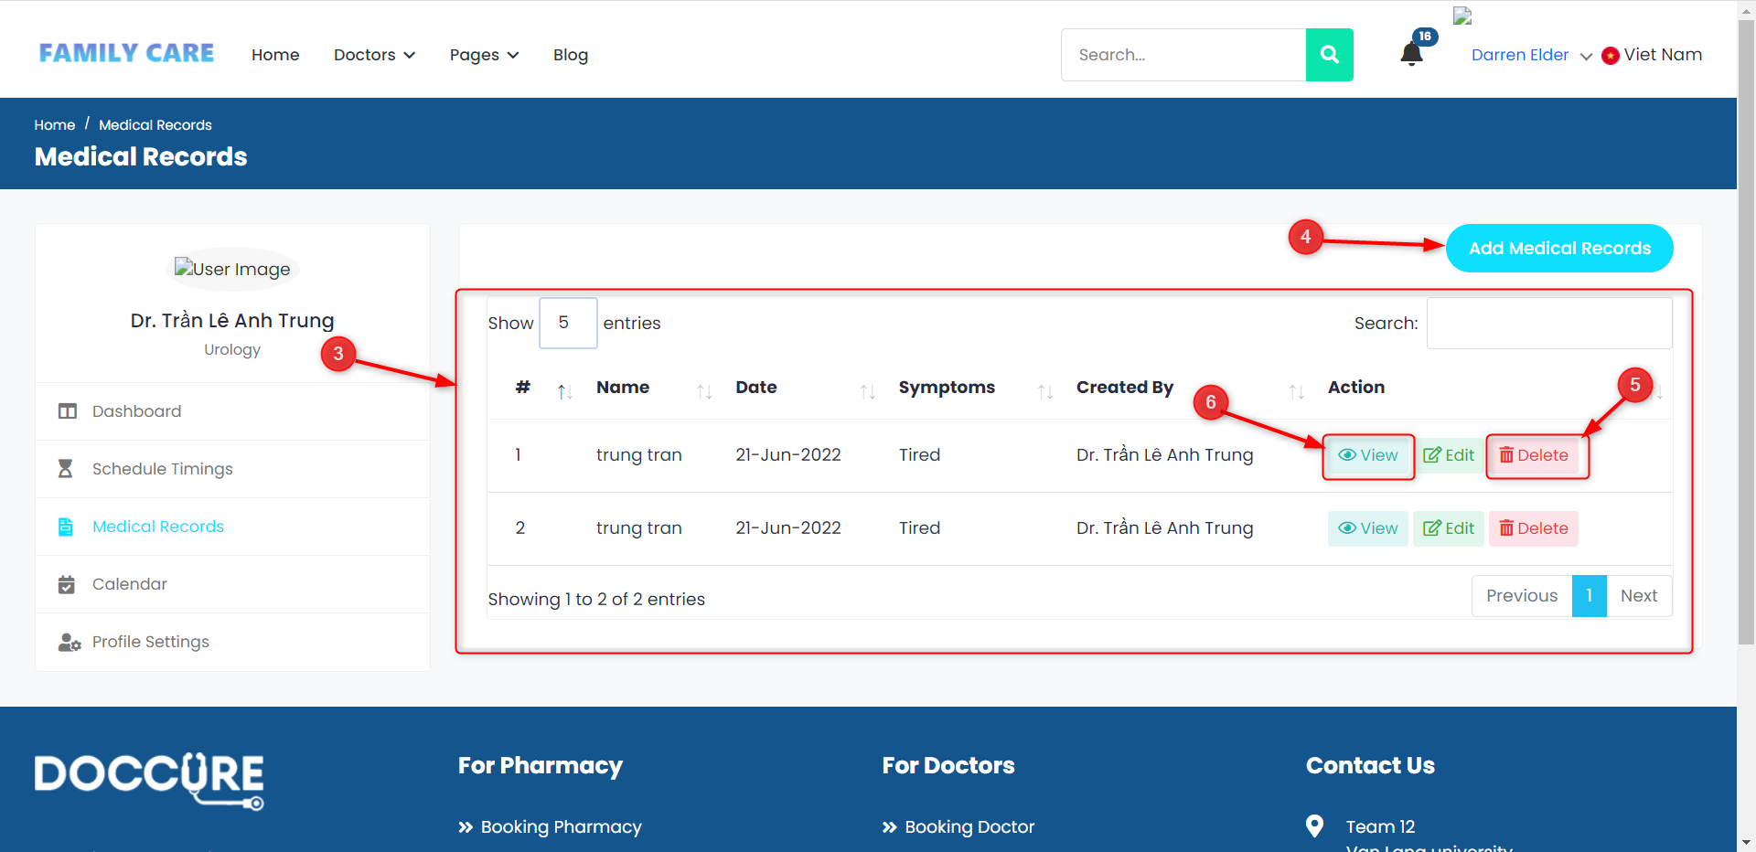

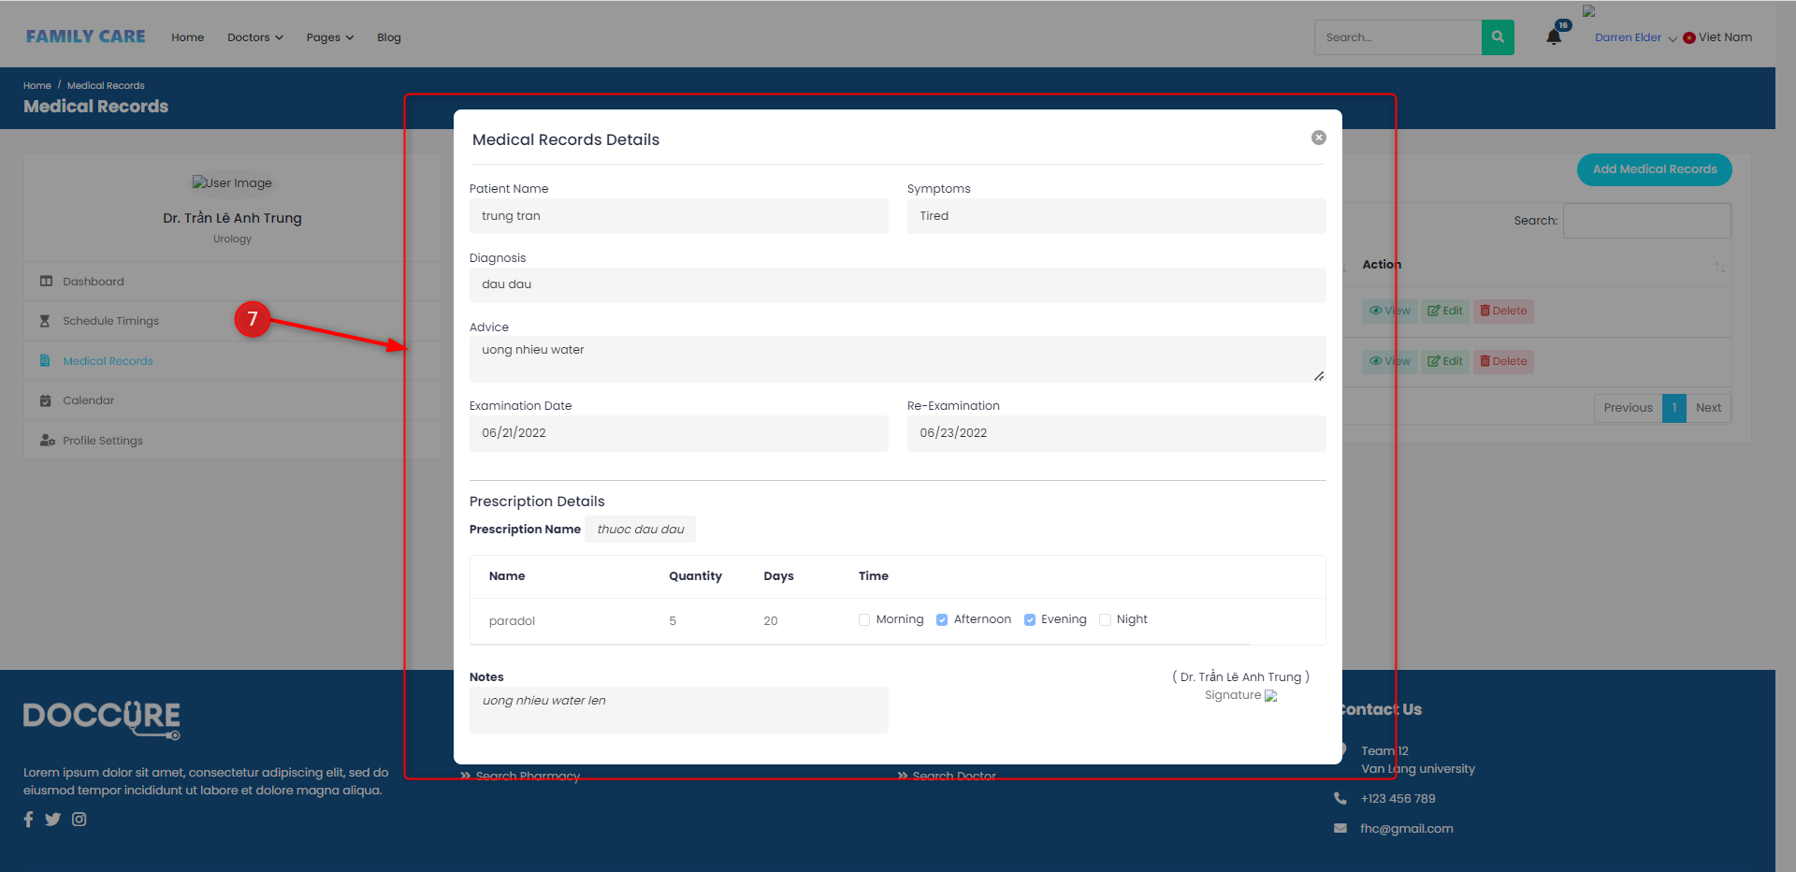

* Step 1: Click to " Doctor " (1)
* Step 2: Click on " Medical record "(2)
* Step 3: Website show details medical records (3)
* Step 4: Click button view (5)
* Step 5: Website show detail of medical record (7)

Add medical records:

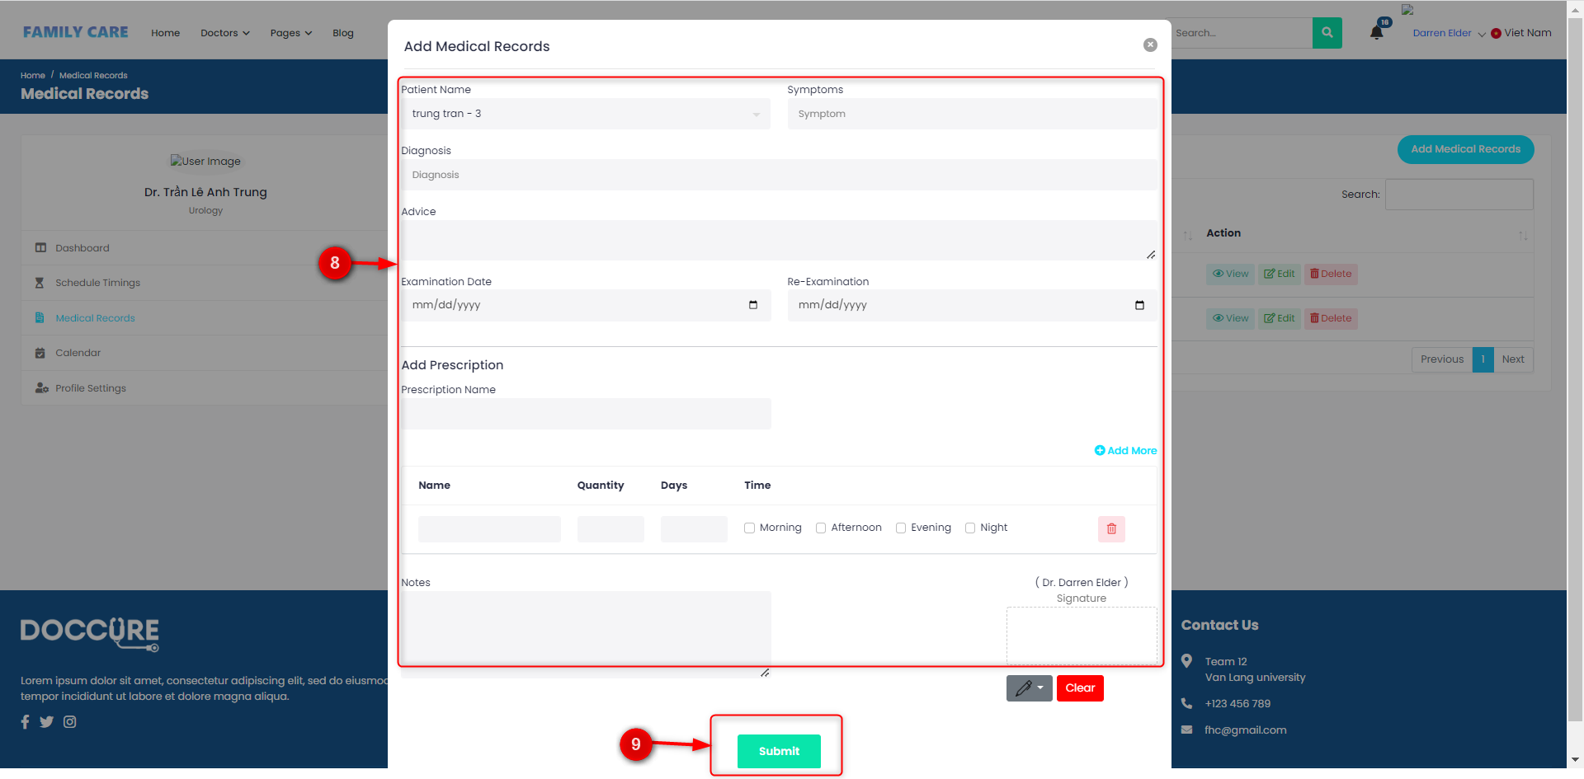

* Step 1: Click to " Doctor "(1)
* Step 2: Click on " Medical record "(2)
* Step 3: Website show details medical records (3)
* Step 4: Click Add medical record (4)
* Step 5: Website display popup you enter the information fields in (8)
* Step 6: Click Submit (9)

Delete medical records:

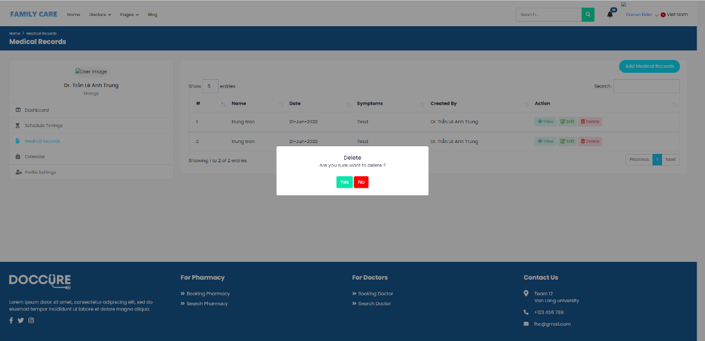

* Step 1: Click to " Doctor "(1)
* Step 2: Click on " Medical record "(2)
* Step 3: Website show details medical records (3)
* Step 4: Click Delete (5)
* Step 5: Website display popup notification (10)

## Calendar page of the system

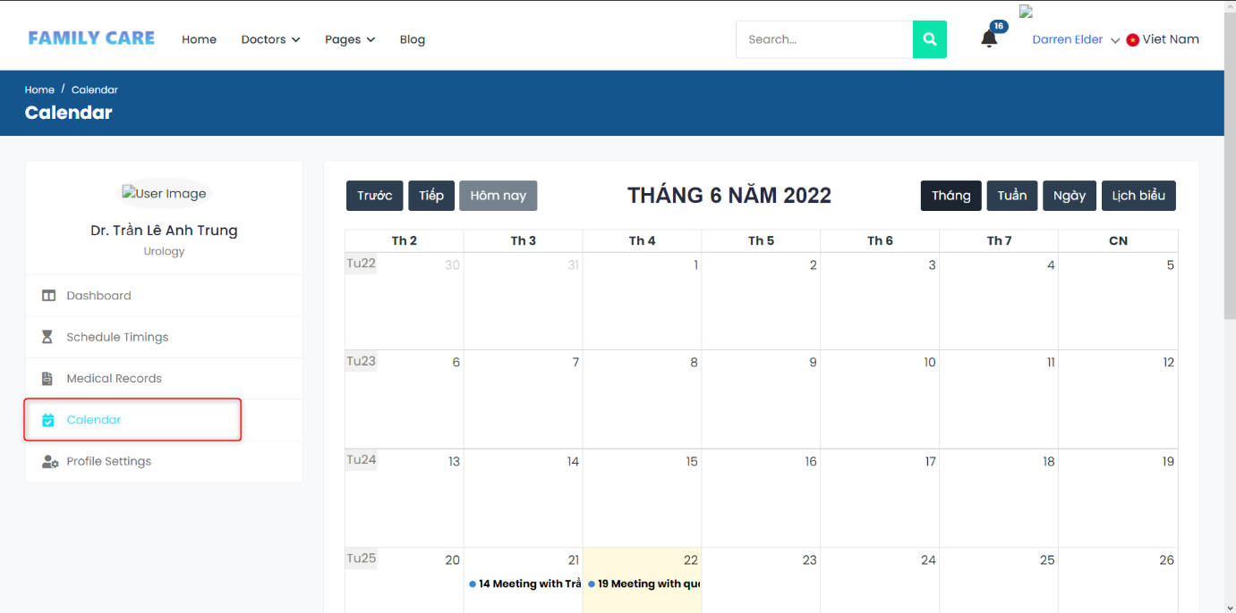

Calendar page:

* Step 1: Click on " Calendar " to view list
* Step 2: System show calendar

## Profile setting Page of the system

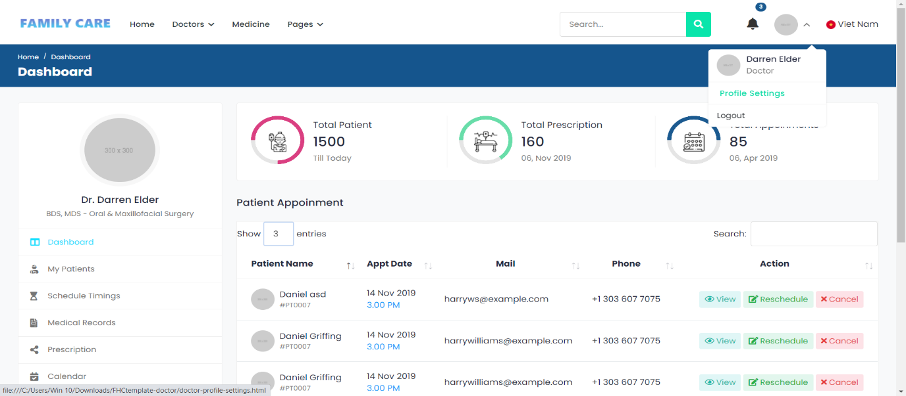

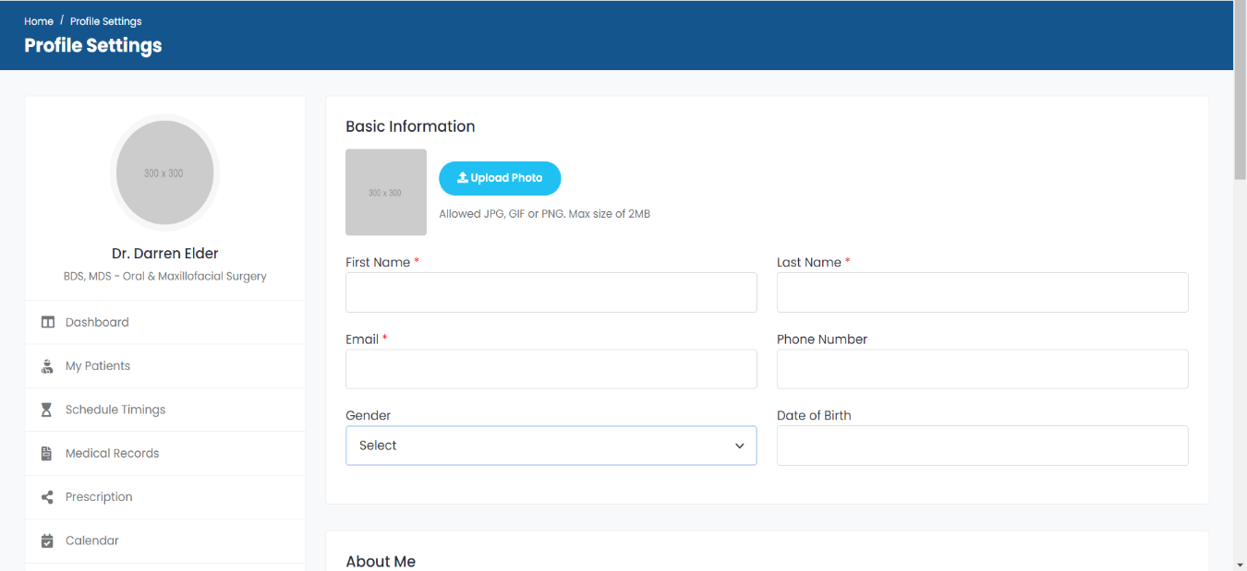

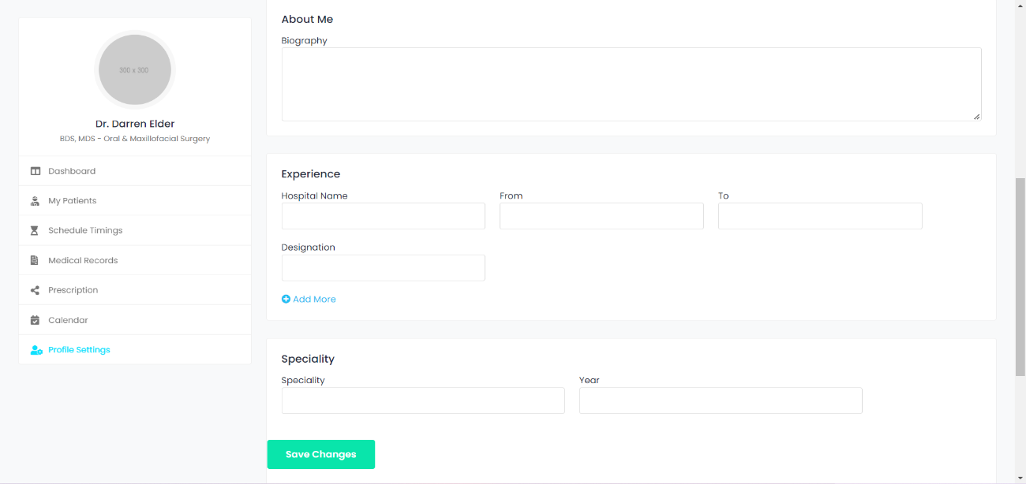

Profile setting:

* Move the mouse pointer drop-down to see the list in common and select “Profile Settings”
* The Profile setting page appears for the doctor view

# Pharmacy View:

## Login page as Pharmacy of the system

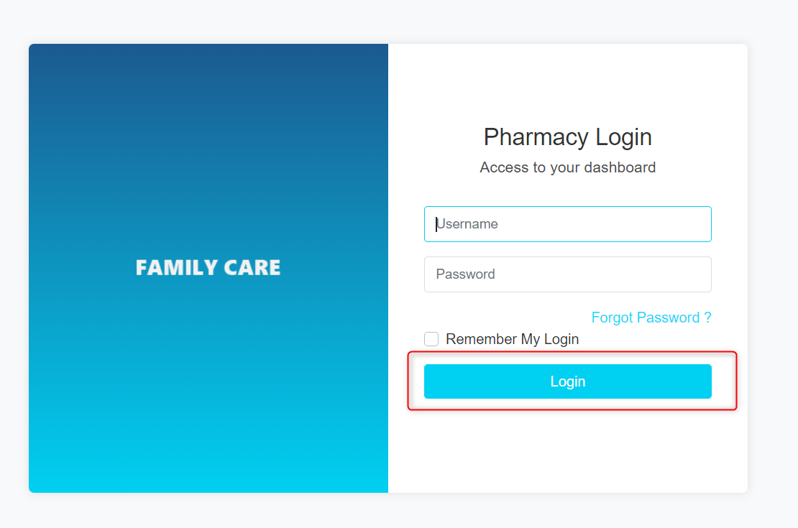

Login page interface: Pharmacies log into the system with the account provided by the system

### Homepage for Pharmacy

After login, system display admin interface

Main page interface, displayed information: Statistical, Latest Customers

### CRUD for Medicine: Management page "Medicine" for Pharmacy, can add delete and edit products

#### View list of registered medicine

Precondition: The system is working and user successfully logged in as "Pharmacy"

* Step 1: Pharmacies selects menu "Medicines"
* Step 2: Pharmacies selects "Medicines" to view list of medicine

#### View detail medicine

Precondition: The system is working and user successfully logged in as "Pharmacy"

* Step 1: Pharmacies selects menu "Medicines"
* Step 2: Pharmacies selects "Medicines" to view list of medicine
* Step 3: Select on any medicine to view details about medicine

#### Add medicine

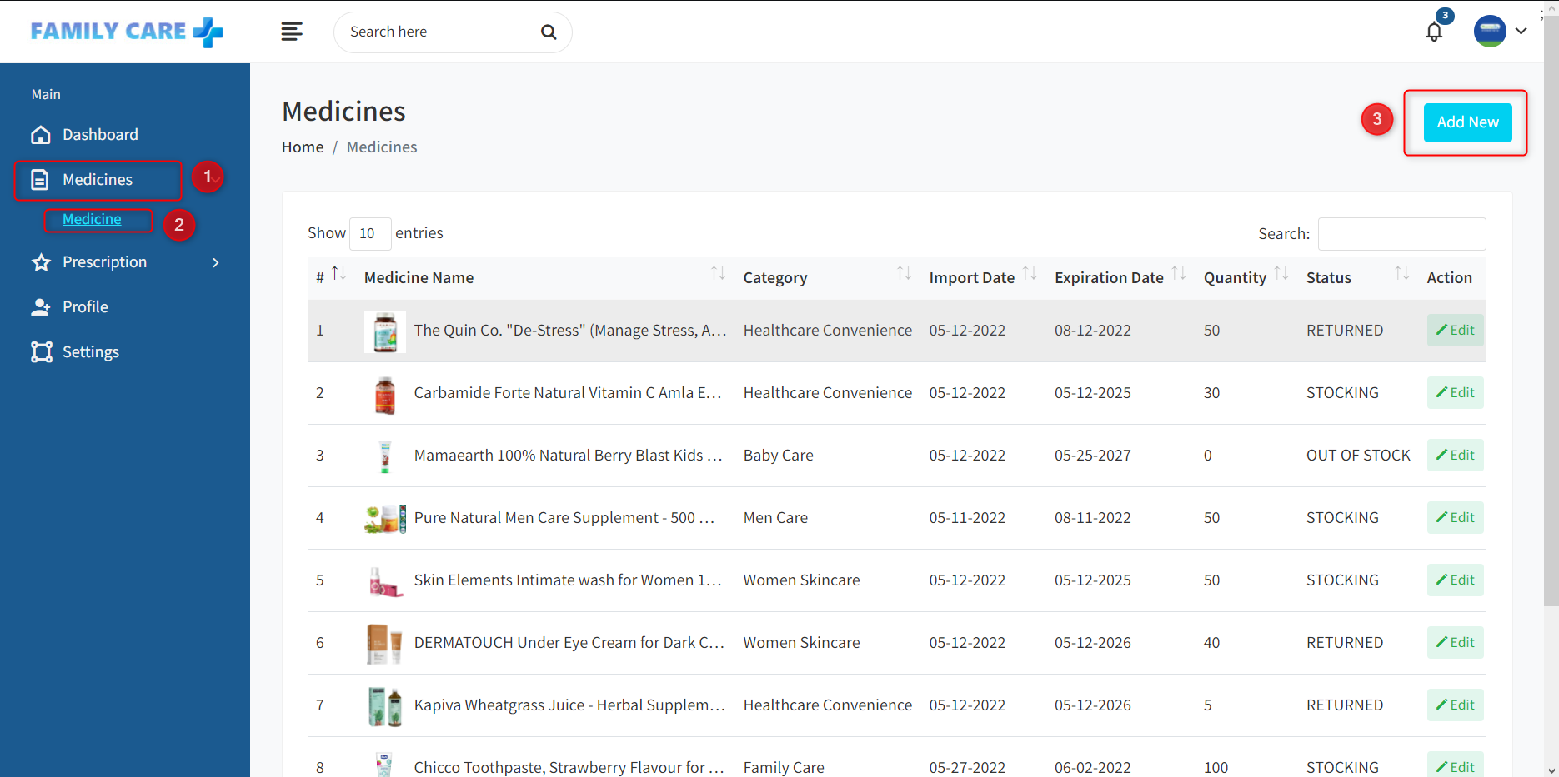

Precondition: The system is working and user successfully logged in as "Pharmacy"

* Step 1: Pharmacies selects menu "Medicines"
* Step 2: Pharmacies selects "Add Medicine" to add new medicine
* Step 3: System show popup Add medicine
* Step 4: Pharmacies enter all fields to create new medicine
* Step 5: Pharmacies click saves change to create new medicine successfully

#### Update medicine

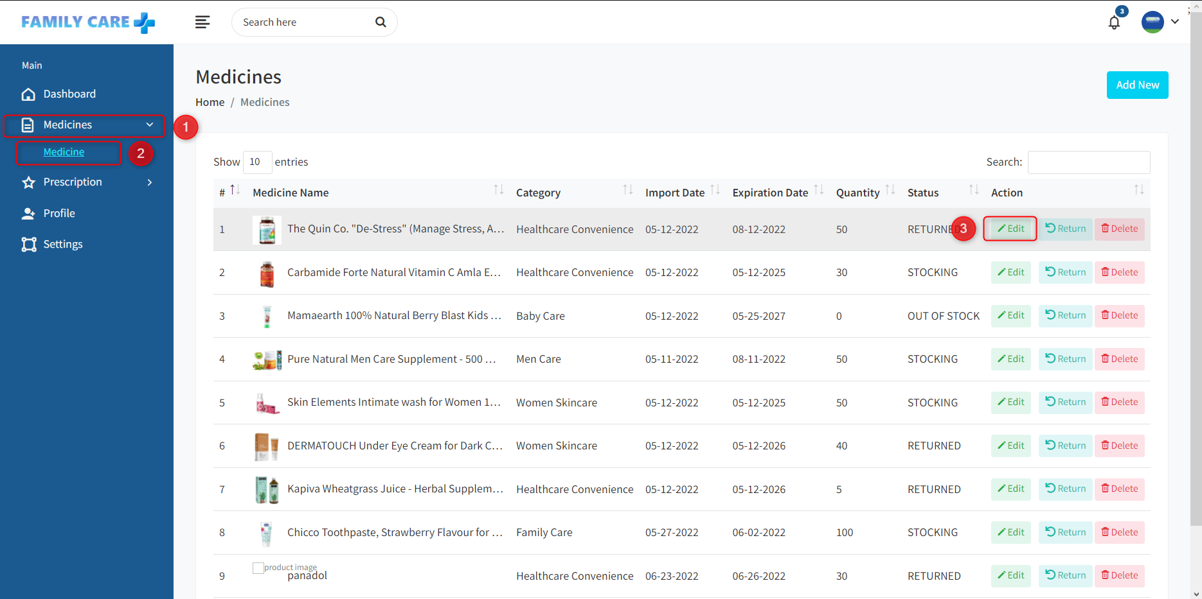

Precondition: The system is working and user successfully logged in as "Pharmacy"

* Step 1: Pharmacies selects menu "Medicines"
* Step 2: Pharmacies selects "Medicines" to view list of medicine
* Step 3: Select on "Edit" to update medicine
* Step 4: System show popup edit medicine
* Step 5: Pharmacies enter field need to edit
* Step 6: Pharmacies click saves change to edit successfully

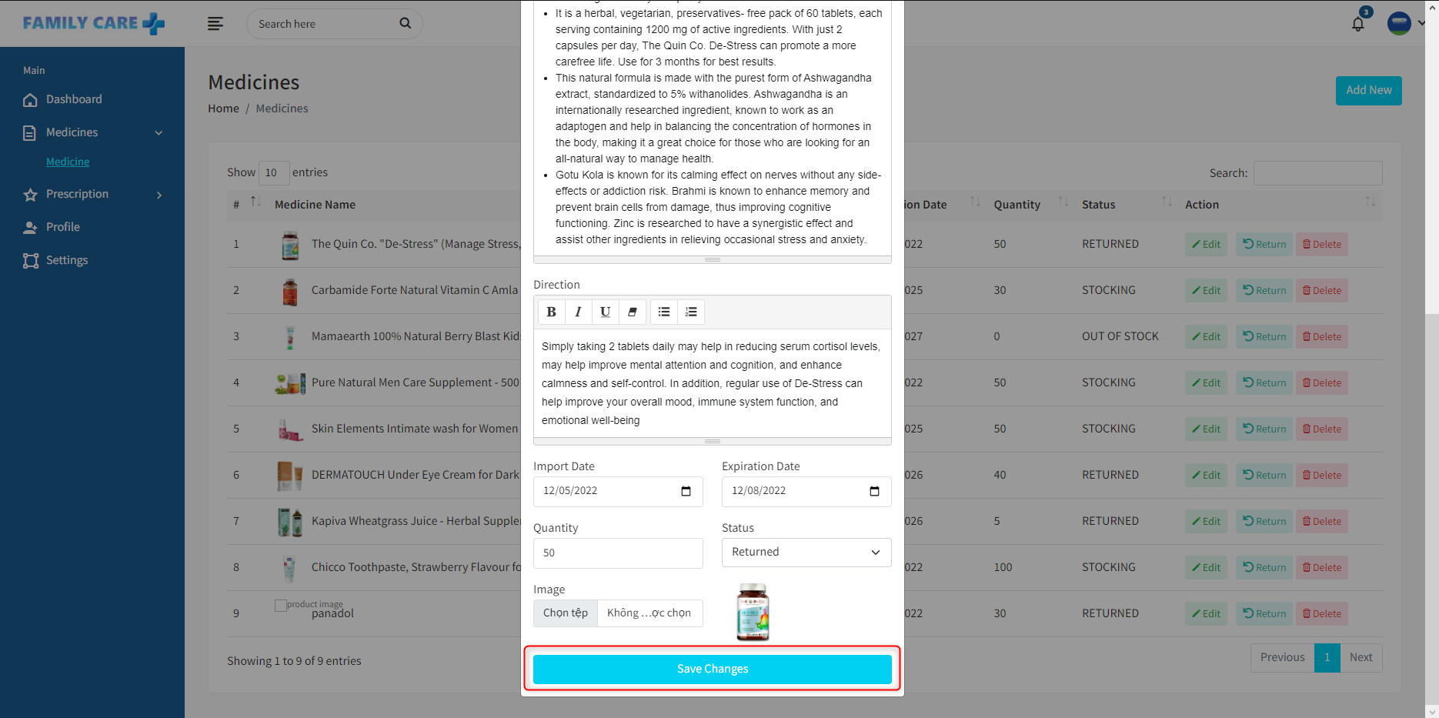

#### Return medicine

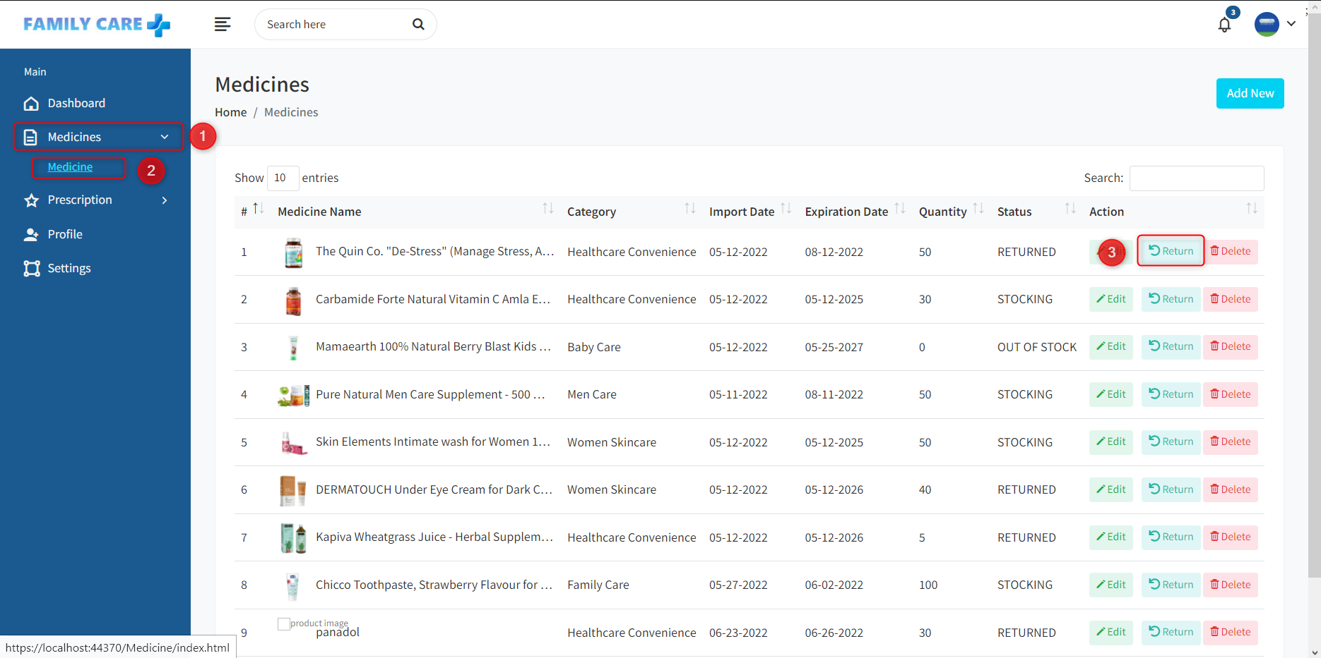

Precondition: The system is working and user successfully logged in as "Pharmacy"

* Step 1: Pharmacies selects menu "Medicines"
* Step 2: Pharmacies selects "Medicines" to view list of medicine
* Step 3: Select on "Return" to return medicine
* Step 4: System show popup return medicine
* Step 5: Click on return to return successfully

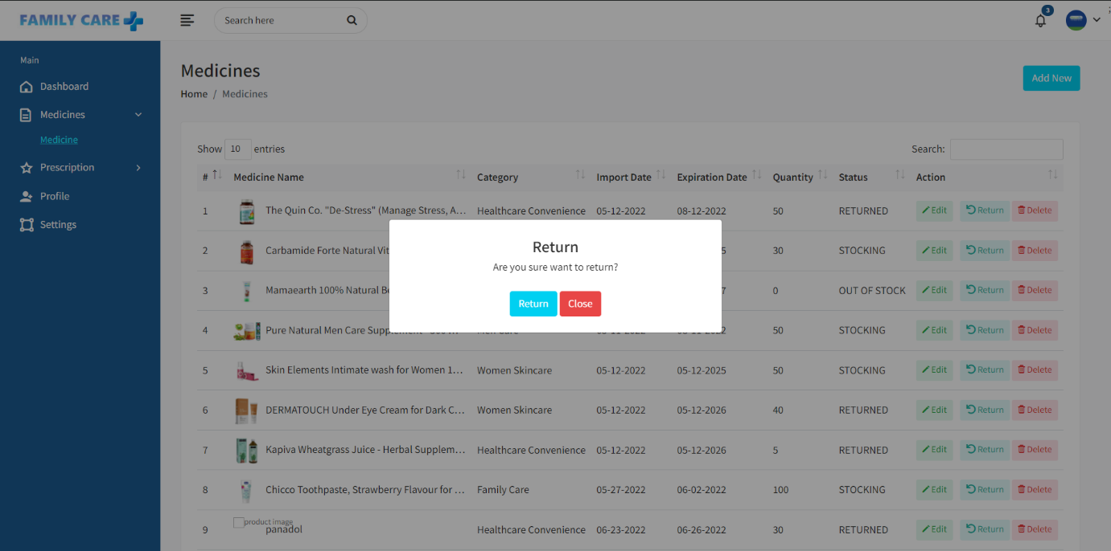

#### Delete medicine

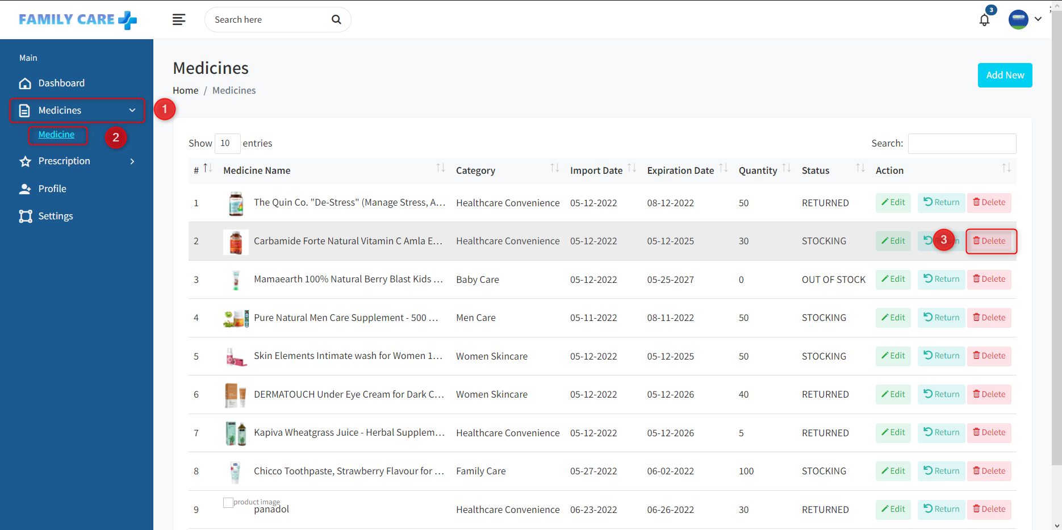

Precondition: The system is working and user successfully logged in as "Pharmacy"

* Step 1: Pharmacies selects menu "Medicines"
* Step 2: Pharmacies selects "Medicines" to view list of medicine
* Step 3: Select on "Delete" to delete medicine
* Step 4: System show popup delete medicine
* Step 5: Pharmacies click on save to delete medicine successfully

### CRUD for Prescription: Management page "Prescription" for Pharmacy, can add delete and edit products

#### View list of prescriptions

Precondition: The system is working and user successfully logged in as "Pharmacy"

* Step 1: Pharmacies selects menu "Prescription"
* Step 2: Pharmacies selects " Prescription " to view list of prescription

#### Add prescription

Precondition: The system is working and user successfully logged in as "Pharmacy"

* Step 1: Pharmacies selects menu "Prescription"
* Step 2: Pharmacies selects " Prescription " to view list of prescription
* Step 3: Pharmacies selects "Add new " to add new prescription
* Step 4: System show popup create new prescription
* Step 5: Pharmacies fill all fields to create prescription
* Step 6: Pharmacies click on Submit to create prescription successfully

#### Update prescription

Precondition: The system is working and user successfully logged in as "Pharmacy"

* Step 1: Pharmacies selects menu "Prescription"
* Step 2: Pharmacies selects "Prescription" to view list prescription
* Step 3: Select on "Edit" to edit prescription
* Step 4: System show popup edit prescription
* Step 5: Pharmacies enter field need to edit
* Step 6: Click on Submit to edit prescription successfully

#### Delete prescription

Precondition: The system is working and user successfully logged in as "Pharmacy"

* Step 1: Pharmacies selects menu "Prescription"
* Step 2: Pharmacies selects "Prescription" to view list prescription
* Step 3: Select on "Delete" to show popup delete prescription
* Step 4: System show popup delete
* Step 5: Click on yes to delete prescription

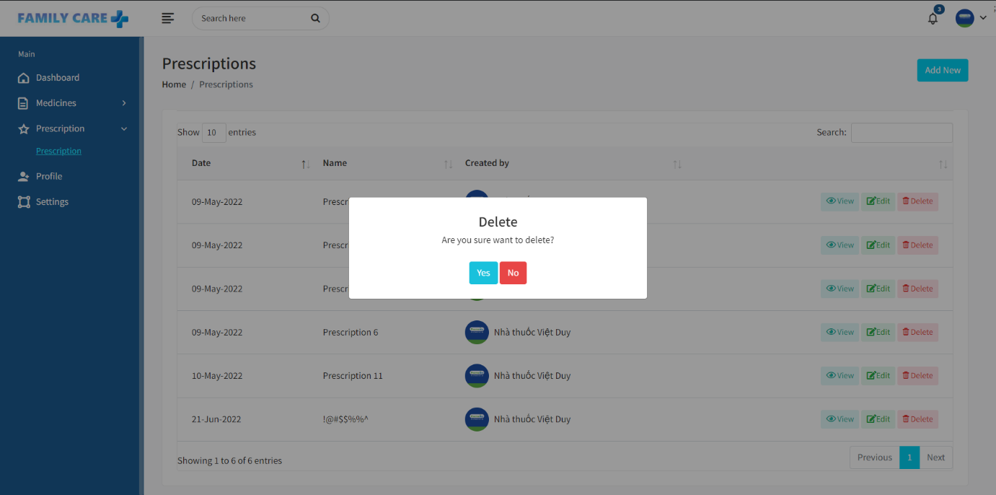

### View Notifications

Precondition: The system is working and user successfully logged in as "Pharmacy"

* Step 1: Pharmacies select the "Bell" icon to see notifications
* Step 2: Select any notification to view details

### Change Password

Precondition: The system is working and user successfully logged in as "Pharmacy"

* Step 1: Pharmacies select the "User" icon to see profile
* Step 2: Pharmacies select "My profile" to view details profile
* Step 3: Select on "Password" to change pasword

### Change Languages

Precondition: The system is working and user successfully logged in as "Pharmacy"

* Step 1: Pharmacies select the "Language" icon to see display languages
* Step 2: Select any language to change the display language

### Settings Website

Precondition: The system is working and user successfully logged in as "Pharmacy"

* Step 1: Pharmacies select "Settings" for system installation